Lab Assignment 9
K Vignanand Rao
2303A52439
Batch 41

Task 1: Email Validation using TDD
Prompt:
Email verification checker
Generate all possible test cases for email verification checker and verify the output with the expected output
Code:
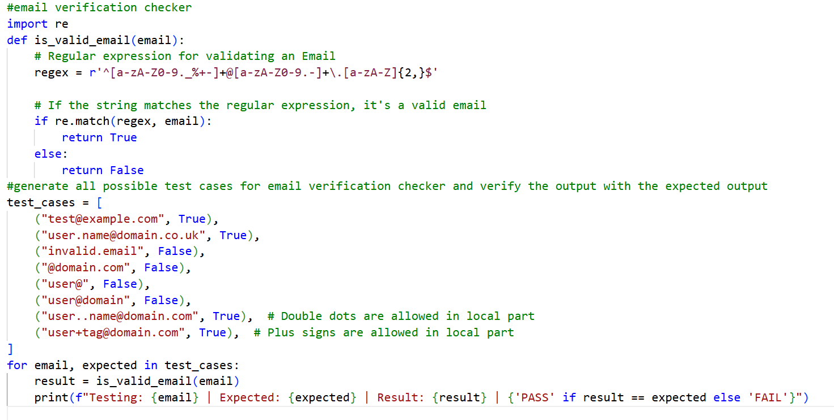

Output:
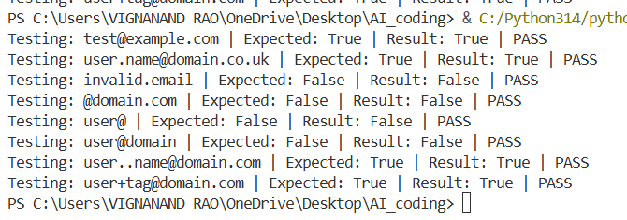
Justification:
By this activity or task, we are checking or validating the code which is given by ai with all the possible test cases possible, with the requirements given in the scenario. This helps in verification of the code.

Task 2: Grade Assignment using Loops
Prompt:
Grade calculator for students with 90-100 as A, 80-89 as B, 70-79 as C, 60-69 as D and below 60 as F and also having invalid inputs like negative marks or marks greater than 100 and marks in words
Generate all possible test cases for grade calculator and verify the output with the expected output
Code:
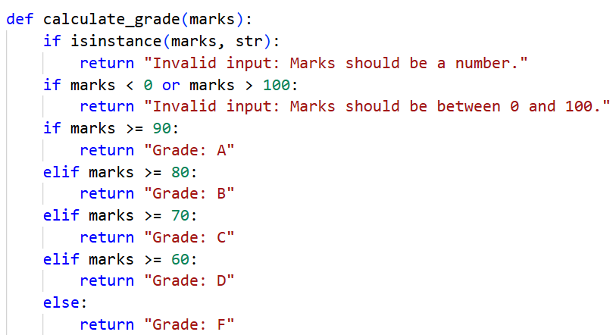
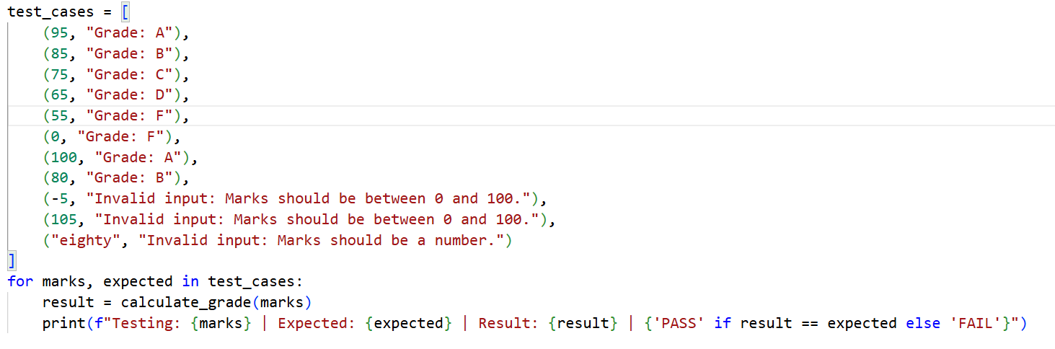
Output:
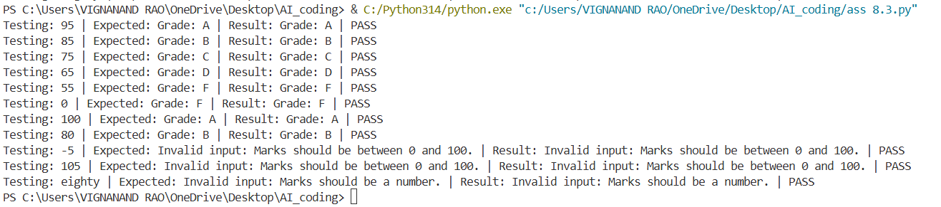
Justification:
By this activity, we can check the given grade calculator code generated by ai with all the possible test cases. In the test cases generated by ai, all the possible test cases are involved such as edge cases like 80,100 and also the least score 0 and highest score 100 is being checked. We are also checking the values like -5 and 105 which are not possible marks to be scored by a student. This perfect code is very useful to find the grade accurately.

Task 3: Sentence Palindrome Checker
Prompt:
Palindrome checker for sentences ignoring spaces, punctuation and case sensitivity
Code:
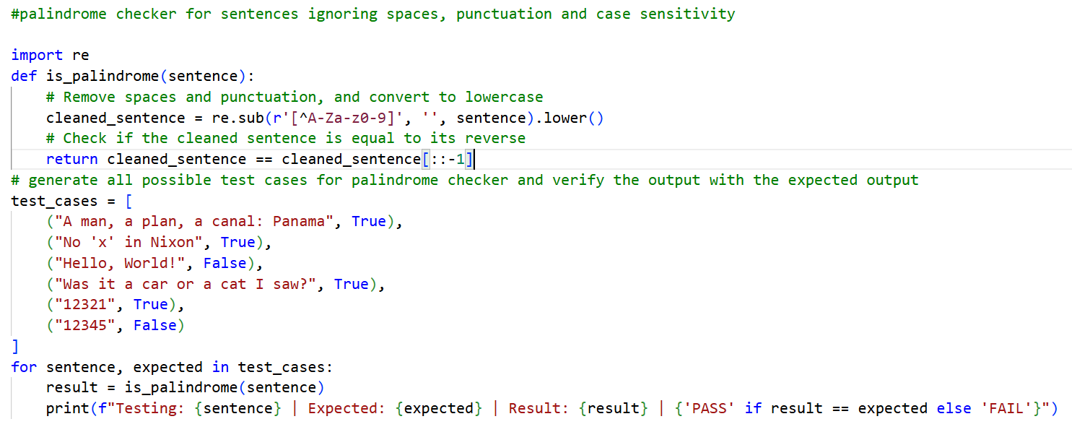
Output:
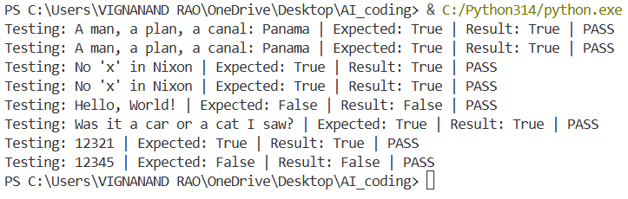
Justification:
By this task, we are able to detect the palindrome sentence. We are checking whether the sentence is a palindrome or not with the help of ai generated code and verifying all the possible test cases, we are also including the sentences having punctuations and spaces by eliminating them for easy identification.
Task 4: ShoppingCart Class
Prompt:
Shopping cart class with add, remove, total cost methods.
Generate all possible test cases for shopping cart class and verify the output with the expected output, also check with empty cart and only say whether the test case passed or failed without printing the expected and actual output.
Code:
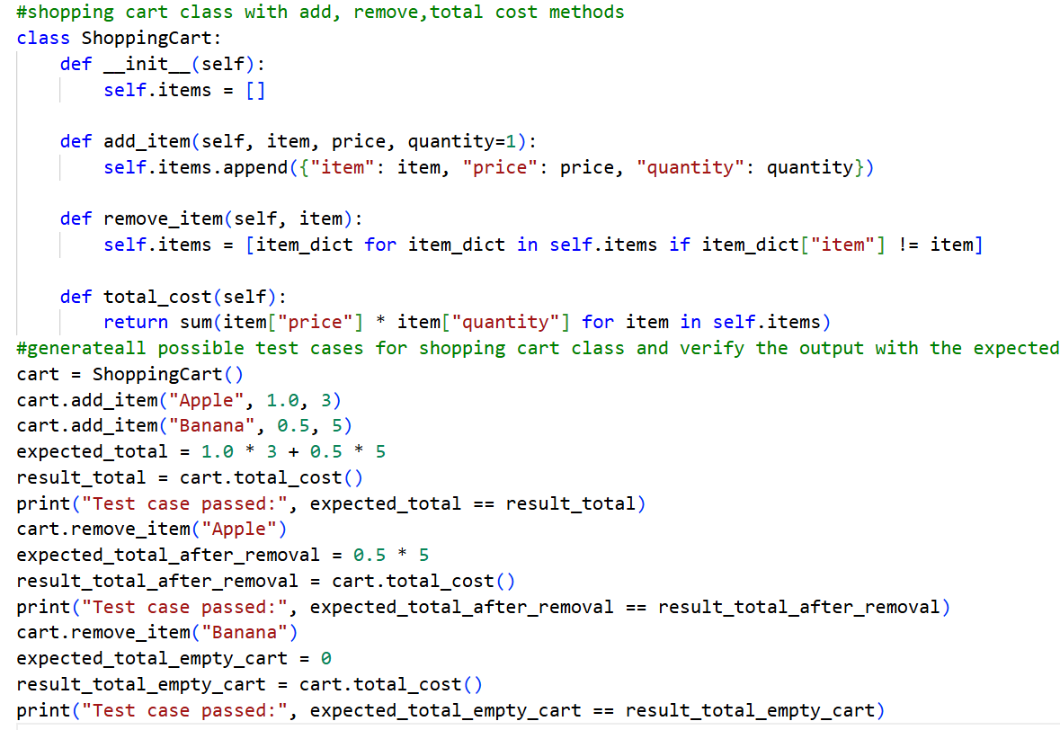
Output:
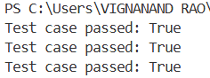
Justification:
By this activity or task, we are validating the code generated by ai on shopping cart class with all required methods, when we verified the code all the testcases are passed which results that the given code is accurate for the scenario.
Task 5: Date Format Conversion
Prompt:
Date format converter from YYYY-MM-DD to DD-MM-YYYY and also handle invalid date formats and invalid dates.
Code:
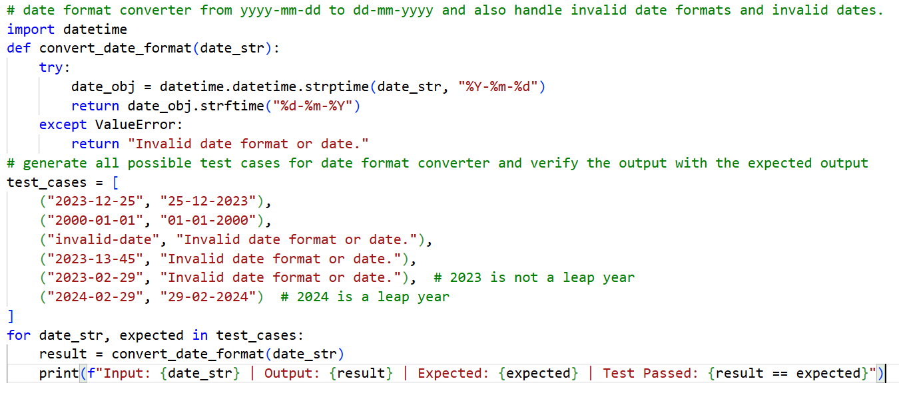
Output:
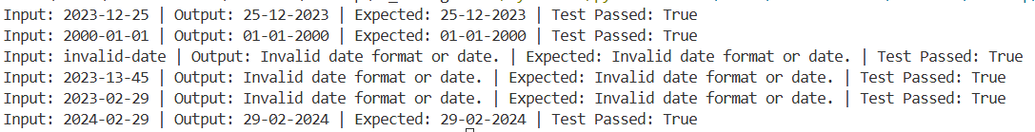
Justification:
By this task or activity, we are able to convert the date format from YYYY-MM-DD to DD-MM-YYYY. When we have done the verification process, we can clearly see that all the possible test cases are being checked and outputs are as expected. The code also checking whether the date is valid date or not like more than 12 months, number of days in that certain month and also the important thing is checking the year is leap year or not to find the number of days in February which increases the more accuracy and helps in passing all the test cases out there which is important thing to be done.

